Course : Diploma in Multimedia & Infocomm Technology (EGDF15)

Module : Java Enterprise Development (EG3752)

|  |  |
| --- | --- |
| Laboratory : | Project |
| Objectives : | This project allows you to build mini enterprise level application using Servlets, JSPs and JDBC |
| Software Used : | Java Standard Development Toolkit (JDK™) 8.0  NetBeans IDE 8.0 with GlassFish Server 4.0  MySQL Community Edition 5.7 or WAMP Server + MySQL Workbench 6.3 |

# Project – Aleksi Computers Inc Online Shopping Portal

Table of Contents

Project – Aleksi Computers Inc Online Shopping Portal 2

System Overview 3

Package and Deployment 3

Milestones (Assessment Criteria) 3

Deliverable #1: Sequence Diagram for Shopping Use Case 3

Deliverable #2: Setup Development Environment on Laptops 3

Deliverable #3: Project Submission 3

Appendix A: System Features 4

Use Case Diagram of the System 4

Activity Diagrams 5

1. User Login and Registration Process 5

2. Search Process 5

3. Shopping Process 6

4. Checkout Process 6

Requirements 7

1. User Account Sub-module 7

2. Shopping Sub-module 8

3. Order Sub-module 9

Database Design 9

Appendix B: User Acceptance Test – Test Scenarios 12

User Account Sub-module 12

Shopping Sub-module 12

Order Sub-module 12

Points-related Functionality 12

Appendix C: Late Submission Policy 13

Appendix D: Detailed Breakdown of Scores 14

# System Overview

You are tasked to write an online shopping portal using Java EE for Aleksi Computers Inc.

You will be developing the customer module comprising three sub-modules namely, **user account**, **shopping** and **order** sub-modules. The web application must be compatible with Mozilla Firefox and Google Chrome. All requirements are documented in **Appendix A**.

## Package and Deployment

As the final application will be hosted under *www.aleksi.com*, package your sub-module under the **com.aleksi** package name.

# Milestones (Assessment Criteria)

This project is divided into two portions: Design and Implementation. The design portion carries 5% of the marks while the implementation portion carries 30%.

Table 1 shows the major deliverables, deadlines and corresponding weightage of the project.

|  |  |  |
| --- | --- | --- |
| **Deliverables** | **Deadline** | **Weightage (%)** |
| **Design** | | |
| 1. Sequence Diagram for **Shopping** Process | Week 5 | 5 |
| **Implementation** | | |
| 2. Setup Development Environment on Laptops | Week 5 | 2 |
| 3. Project Submission | Week 8 - 10 | 28 |

Table 1: List of Major Deliverables

## Deliverable #1: Sequence Diagram for Shopping Use Case

Study the self-directed learning module on BlackBoard to learn how to draw a sequence diagram. It is found under **Self-Directed Learning > Sequence Diagram [Week 3]**.

Submit a copy of asequence diagram representing the **Shopping** use case. This can be hand drawn or done with a software such as Visual Paradigm.

## Deliverable #2: Setup Development Environment on Laptops

Bring your laptop with the development environment set up. All necessary software for the development of the project must be installed and the basic project structure built.

## Deliverable #3: Project Submission

Submit the completed project by scheduling a timeslot meet your accessor **before the project deadline**. The web portal will be subjected to a stringent User Acceptance Test (UAT) (see **Appendix B**). You will also need to go through a Question & Answer session. Marks will be deducted for late submission according to the policies laid out in **Appendix C**.

A slightly more detailed breakdown of the scores can be found in **Appendix D**.

# Appendix A: System Features

The next few pages of this document will describe the system features that needs to be implemented in the project.

## Use Case Diagram of the System

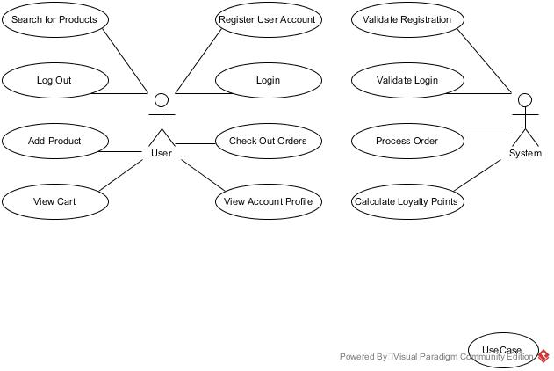

## Activity Diagrams

The following activity diagrams will describe selected use cases with regards to the user login and registration process and the shopping process.

### 1. User Login and Registration Process

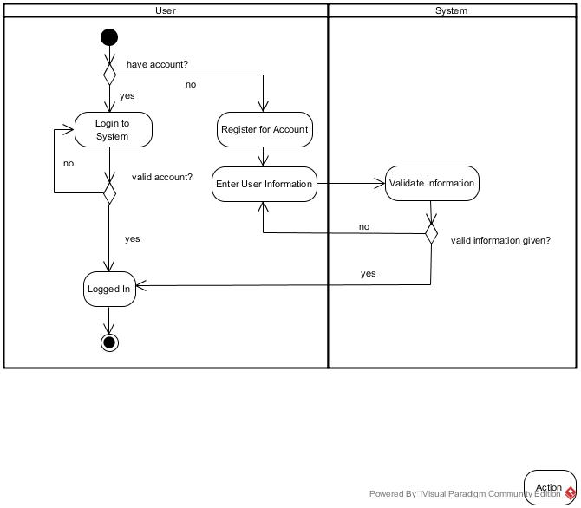

### 2. Search Process

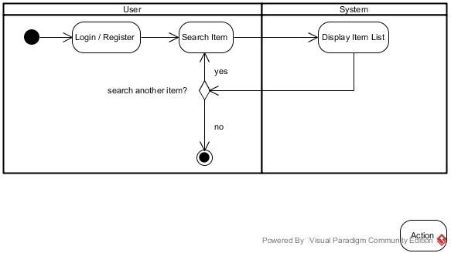

### 3. Shopping Process

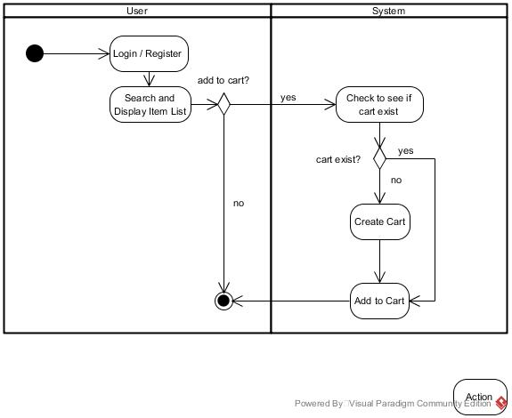

### 4. Checkout Process

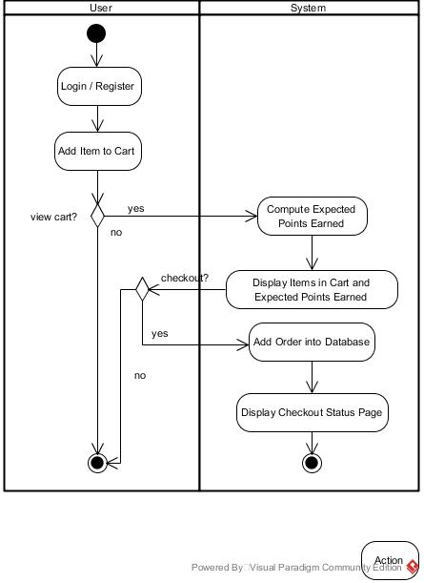

## Requirements

The next few tables will describe the requirements specifications for the three main sub modules of the system.

### 1. User Account Sub-module

|  |  |
| --- | --- |
| **Requirement Reference** | **Requirement Specifications** |
| 1.1 User registration | The system shall provide the functionality for users to sign up for a new account.  The system shall allow the user to enter the following information to be entered:   * Full Name * Email * Address Line 1 * Address Line 2 * Postal Code * Mobile Number * Password * Reconfirm Password   The system shall ensure that all information are provided, except for Address Line 2 which can be left blank. |
| 1.2 Registration validation | The system shall ensure the following before the user information is stored in the database:   * Password and reconfirm password field must match * Passwords are pre-hashed with **MD5** algorithm * Email addresss is valid, unique and can only be registered once * Postal code is valid (ie, contain exactly 6 digits) * Mobile number is valid (ie, contain exactly 8 digits)   Upon successful registration of an account, the system shall ensure that users will be logged in automatically and proceed to shop online. |
| 1.3 User login | The system shall provide the functionality for users to login using their email addresses and passwords. |
| 1.4 Login validation | The system shall authenticate the users before proceeding to the shop online page. |

*(continue on next page)*

|  |  |
| --- | --- |
| **Requirement Reference** | **Requirement Specifications** |
| 1.5 View account profile | The system shall allow the user to view his/her account profile when he/she is logged into the system.  The system shall following information:   * Full Name * Email Address * Address Line 1 * Address Line 2 * Postal Code * Mobile Number * Number of Points Obtained so far |
| 1.6 Logout | The system shall provide the user with an option to logout. |

### 2. Shopping Sub-module

|  |  |
| --- | --- |
| **Requirement Reference** | **Requirement Specifications** |
| 2.1 Search items | The system shall allow the user to search for items using partial names of the item.  The system shall display the updated item page based on the search results. |
| 2.2 Display items | For each item, the system shall display the following information:   * Item name * Brand * Price * Points user can earn upon purchase of the item |

### 3. Order Sub-module

|  |  |
| --- | --- |
| **Requirement Reference** | **Requirement Specifications** |
| 3.1 Add order | The system shall allow the user to order the item that is displayed on the shopping page.  The maximum quantity of any item that the user can order is 5. |
| 3.2 Display | The system shall display a success or failure message upon adding the item to the order list. |
| 3.3 View cart | The system shall allow the user to view his/her shopping cart that keep tracks of the items that he/she has added so far.  The system shall allow the user to view the points he/she is expected to earn if the items are checked out. |
| 3.4 Tabulate Cost | The system shall tabulate the costs for each item that is in the order list. |
| 3.5 Checkout | The system shall allow the user to click a link to check out all the orders. |
| 3.6 Display checkout status page | Upon checking out, the system shall display a status page with the following information:   * Full name of the user * Items that he/she has ordered * Total points earned for the order * Total amount he/she is required to pay |

## Database Design

The next few diagrams and tables will describe the database design that will be used for development purposes.

Test data that the development team will be using for all developmental and testing purposes is provided in an SQLDump file named “**EG3752Project.sql**” on Blackboard.

**Diagram 1** shows the entity-relationship diagram of the tables used by the ordering sub-module:

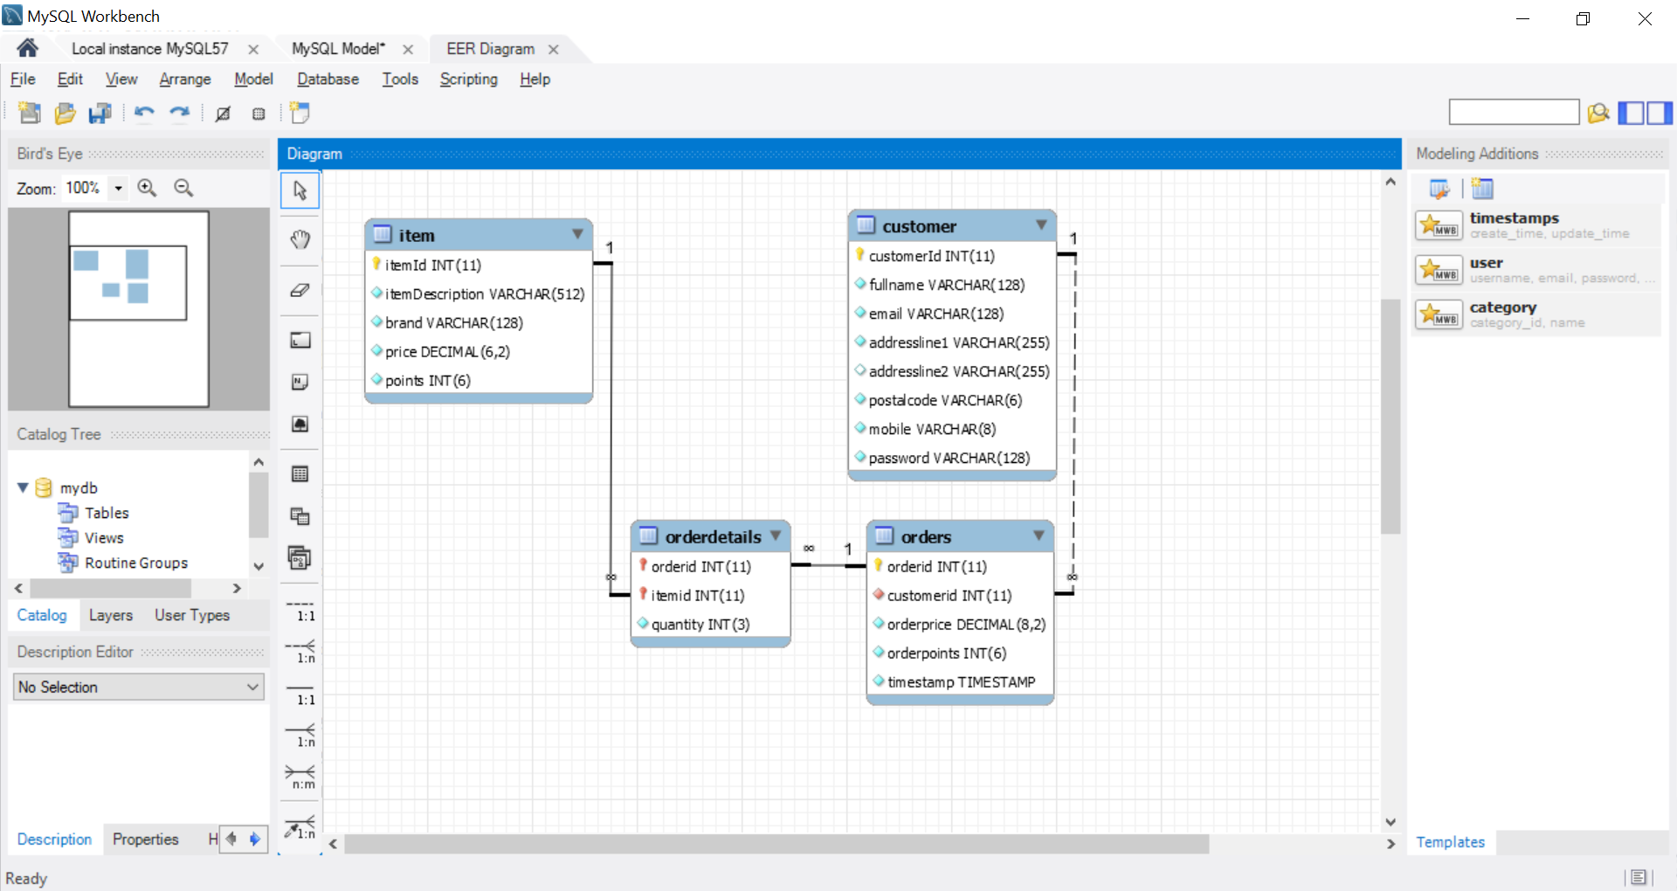

Diagram 1: Entity-Relationship Diagram of the Aleksi Computers Inc Online Shopping Portal

**Tables 2 to 5** show the design of the database tables in details:

|  |  |  |  |
| --- | --- | --- | --- |
| **Column Name** | **Datatype** | **Additional Settings** | **Remarks** |
| itemId | INT(11) | Primary Key, Not Null, Unique, Auto Increment |  |
| itemDescription | VARCHAR(512) | Not Null |  |
| brand | VARCHAR(128) | Not Null |  |
| price | DECIMAL(6,2) | Not Null |  |
| points | INT(6) | Not Null |  |

Table 2: Definition of the **Item** table

|  |  |  |  |
| --- | --- | --- | --- |
| **Column Name** | **Datatype** | **Additional Settings** | **Remarks** |
| customerId | INT(11) | Primary Key, Not Null, Unique, Auto Increment |  |
| fullName | VARCHAR(128) | Not Null |  |
| email | VARCHAR(128) | Not Null |  |
| addressLine1 | VARCHAR(255) | Not Null |  |
| addressLine2 | VARCHAR(255) |  | Default Value: Null |
| postalCode | VARCHAR(6) | Not Null |  |
| mobile | VARCHAR(8) | Not Null |  |
| password | VARCHAR(128) | Not Null | **\*Passwords are pre-hashed using MD5** |

Table 3: Definition of the **Customer** table

|  |  |  |  |
| --- | --- | --- | --- |
| **Column Name** | **Datatype** | **Additional Settings** | **Remarks** |
| orderId | INT(11) | Primary Key, Not Null, Auto Increment |  |
| customerId | INT(11) | Not Null | Foreign Key of the “id” field of **User** table |
| orderPrice | DECIMAL(8,2) | Not Null |  |
| orderPoints | INT(6) | Not Null |  |
| timestamp | TIMESTAMP | Not Null | Default Value: CURRENT_TIMESTAMP |

Table 4: Definition of the **Orders** table

|  |  |  |  |
| --- | --- | --- | --- |
| **Column Name** | **Datatype** | **Additional Settings** | **Remarks** |
| orderid | INT(11) | Primary Key, Not Null | Foreign Key of the “id” field of **Orders** table |
| itemId | INT(11) | Primary Key, Not Null | Foreign Key of the “id” field of **Item** table |
| quantity | INT(3) | Not Null |  |

Table 5: Definition of the **OrderDetails** table

# Appendix B: User Acceptance Test – Test Scenarios

The following test scenarios will be performed during the user acceptance test.

## User Account Sub-module

|  |  |
| --- | --- |
| **Requirement Reference** | **Test Scenario Description** |
| 1.1 User registration  1.2 Registration validation | **Scenario 1:** Test if user is able to register an account |
| 1.3 User login  1.4 Login validation  1.6 Logout | **Scenario 2:** Test if user is able to login and logout. |

## Shopping Sub-module

|  |  |
| --- | --- |
| **Requirement Reference** | **Test Scenario Description** |
| 2.1 Search items | **Scenario 3:** Test if user is able to search for items. |
| 2.2 Display items | **Scenario 4:** Test if user is able to display searched items for ordering |

## Order Sub-module

|  |  |
| --- | --- |
| **Requirement Reference** | **Test Scenario Description** |
| 3.1 Add order  3.2 Display | **Scenario 5:** Test if user is able to add items to cart. |
| 3.3 View cart  3.4 Tabulate cost  3.5 Checkout  3.6 Display checkout status page | **Scenario 6:** Test if user is able to check out and see order summary. |

## Points-related Functionality

|  |  |
| --- | --- |
| **Requirement Reference** | **Test Scenario Description** |
| 1.5 View profile  2.2 Display items  3.3 View cart  3.6 Display checkout status page | **Scenario 7:** Test if user is able to see points-related information at various points in the shopping process |

Defects severity[1] will be assigned to test cases which failed as listed below.

* **Severity 1: Critical –** Program crashes and unable to proceed. For eg, runtime exceptions and page not found.
* **Severity 2: Major –** Unable to execute certain functions.
* **Severity 3: Minor –** Unable to execute certain functions but there are workarounds to the bugs.
* **Severity 4: Trivial –** Does not affect functionality of the program. For eg, spelling errors in the messages, user intuitiveness of the program.

# Appendix C: Late Submission Policy

Marks will be deducted for late submission of the project:

* **On time submission / Late submission with valid arrangements made *before* deadline**  
  Full marks awarded
* **Late submission (1 - 5 working days):**

20 % of the total marks awarded will be deducted

* **Late submission (6 - 10 working days):**

35 % of the total marks awarded will be deducted

* **Late submission (above 10 working days up till week 16 of term):**

50 % of the total marks awarded will be deducted

* **Late submission (beyond week 16 of term) / No submission:**

100 % of the total marks awarded will be deducted

# Appendix D: Detailed Breakdown of Scores

Table D shows a more detail breakdown of the scores for the project. This may help you to strategise on which portion of the project you should put in more effort in.

|  |  |  |
| --- | --- | --- |
| **Deliverables** | **Deadline** | **Weightage** |
| **1. Sequence Diagram for Shopping Process** | **Week 5** | **5** |
| **2. Setup Development Environment on Laptops** | **Week 6** | **2** |
| **3. Project Submission**  User Account Sub-module  Shopping Sub module  Order Sub-module  Points-related Functionalities  Question and Answer | **Week 8 - 10** | **28**  20% of 28  15% of 28  30% of 28  15% of 28  20% of 28 |
| **Total** | | **35** |

1. Definitions for Defects Severity: http://softwaretestingfundamentals.com/defect-severity